**Pumping Station (PS) #3**

IP: 192.168.100:43

Preset: 12

Max. Inner tank: 703 [mm]

**Pumping station (PS) #2**

IP: 192.168.100:42

Preset: 12

**Consumer unit (PU) #3**

IP: 192.168.100:32

Preset: -

District elevation / air pressure: 0.5 [m]

**Consumer unit (PU) #4**

IP: 192.168.100:33

Preset: -

**Lab Init script:**

Script name: “*outer_tanks_init.m”*

PS#2 : Select **Preset 12** -> **Preset 13**

PS#3 : Select **Preset 12** -> **Preset 13**

The init script brings the outer tank levels down to a minimum level. The preset changes open valves, allowing to let the volumes out from the outer tank areas, which are normally closed under control. (Under overflow volume just accumulates in them.) Use this script after tests with heavy overflows.

**Lab connections:**

* PS#3/OUT5 -> PS#3/IN1
* PS#3/OUT3 -> PS#2/IN6
* PS#3/IN4 -> CU#3/OUT1_3
* PS#2/OUT3 -> CU3/IN1_2 (T) (where T is the T joint)
* PS#2/IN7 -> PS#2/OUT5
* PS#2/IN4 -> CU4/OUT1_3
* CU4/IN1_1 -> CU3/IN1_2 (T)

Figure - Consumer unit #3

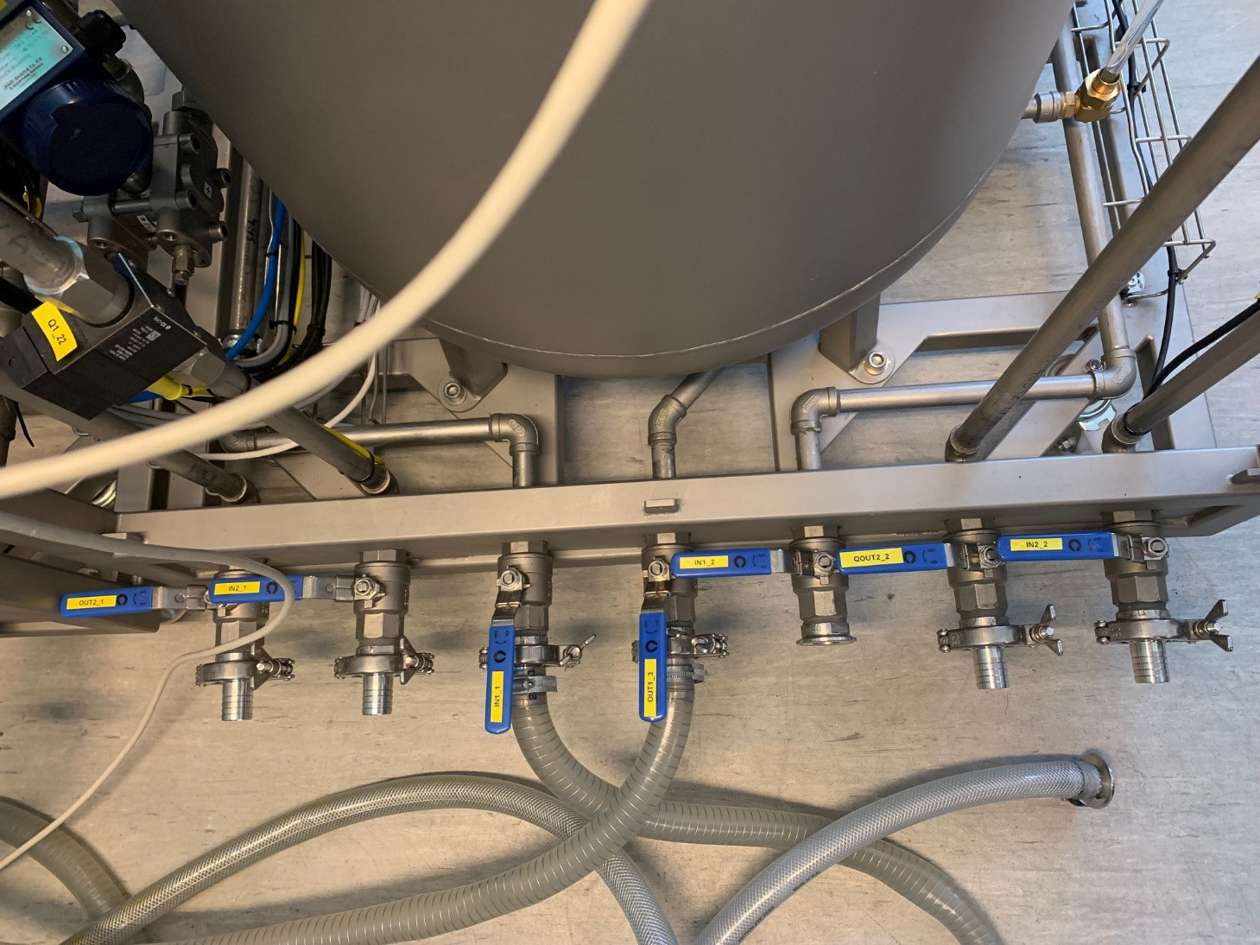

Figure - Consumer unit #4

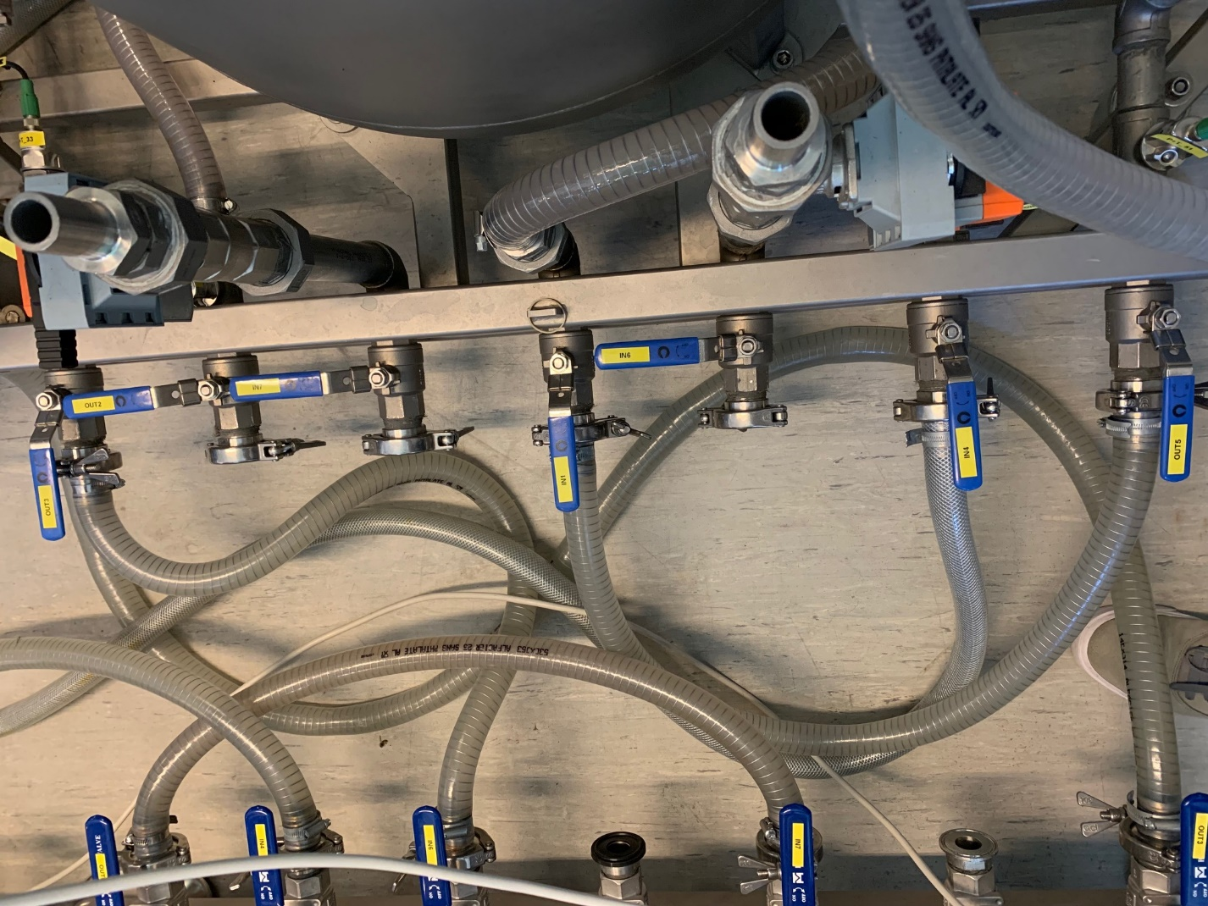

Figure - Pumping station #3

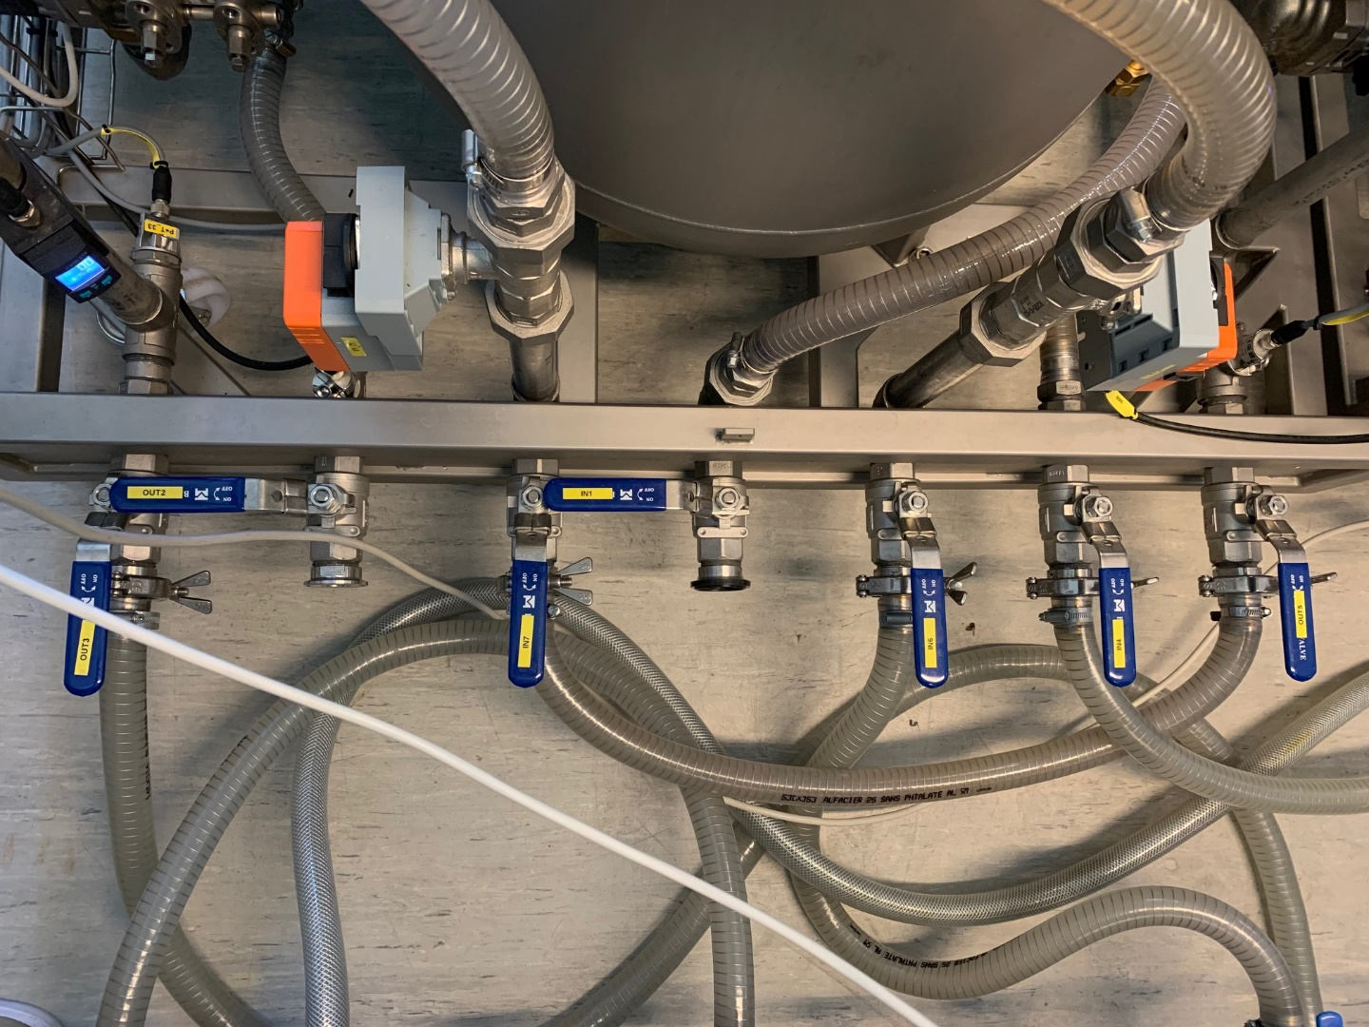

Figure - Pumping station #2

**System fill**

Figure - Pumping station #3 filling tank

**Extra picture documentation:**

Figure - Air pressure supply

Figure - T-joint